DEVOPS Assessment-1

Q) Create Azure Devops Environment and configuring Azure Devops Git Repository ,configure on your local git to implement this upload few test files on same.

Here we need to Create an environment in Azure DevOps and configure a Git repository, and then set it up on your local machine, follow these steps:

First we need to sign in Azure Devops using azure portal.

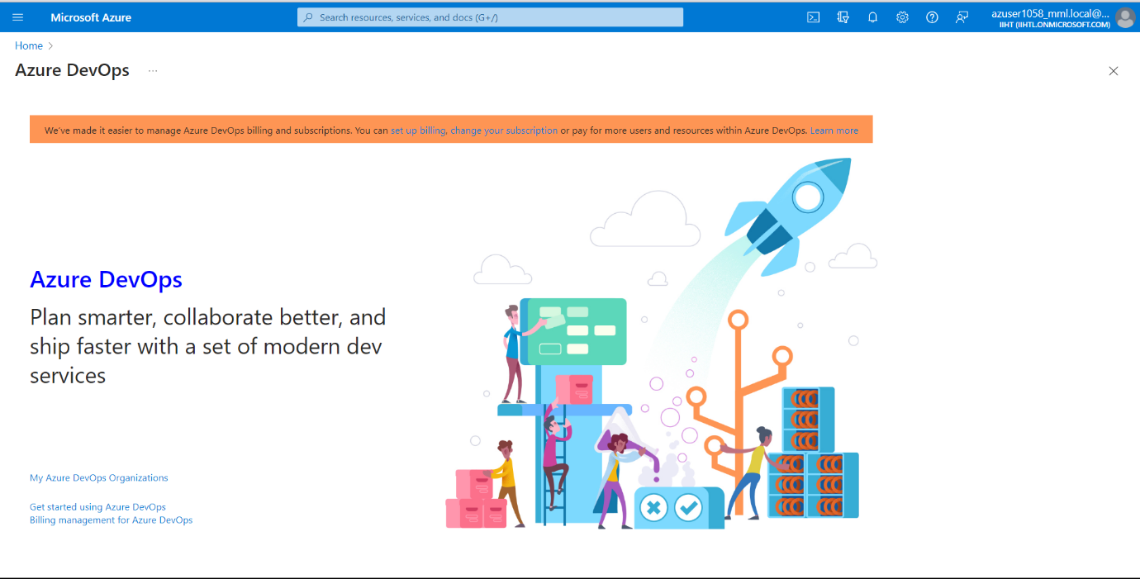

Now let us create a New Project and name is as Demofile and click on Create Project.

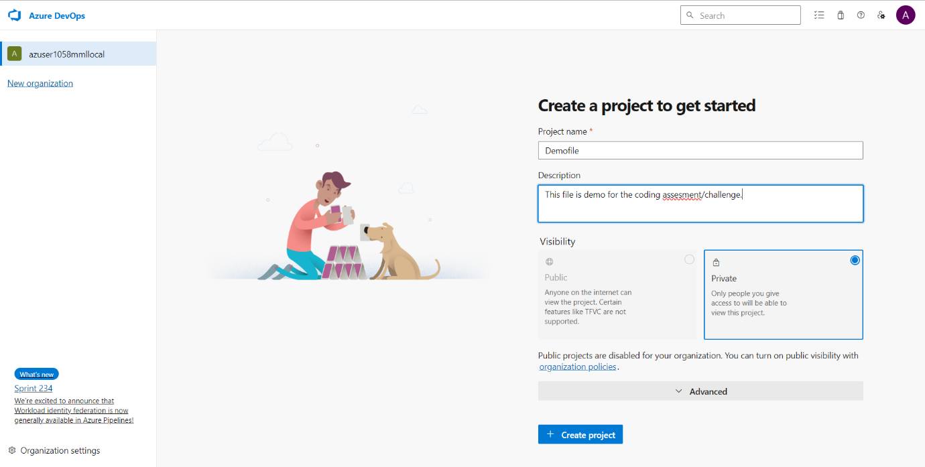

Now this is the home page of your project.

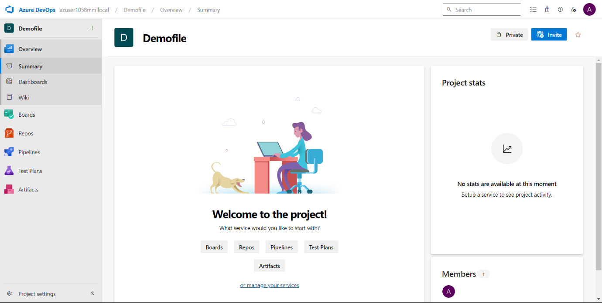

Navigate to Repos and copy the url from Clone to your computer.

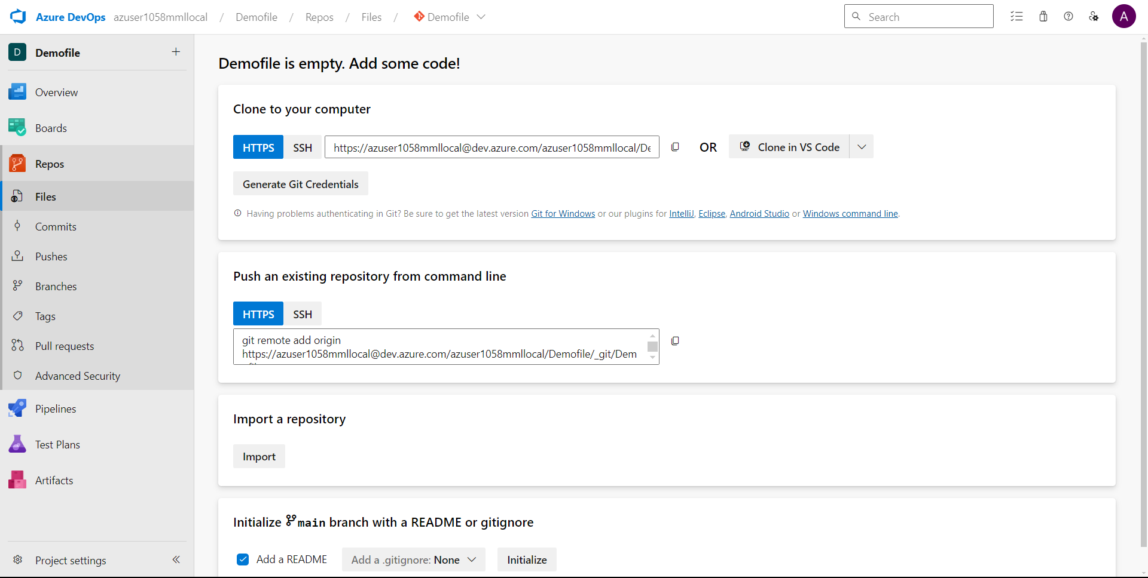

Now open Gitbash in your system by searching in windows search.

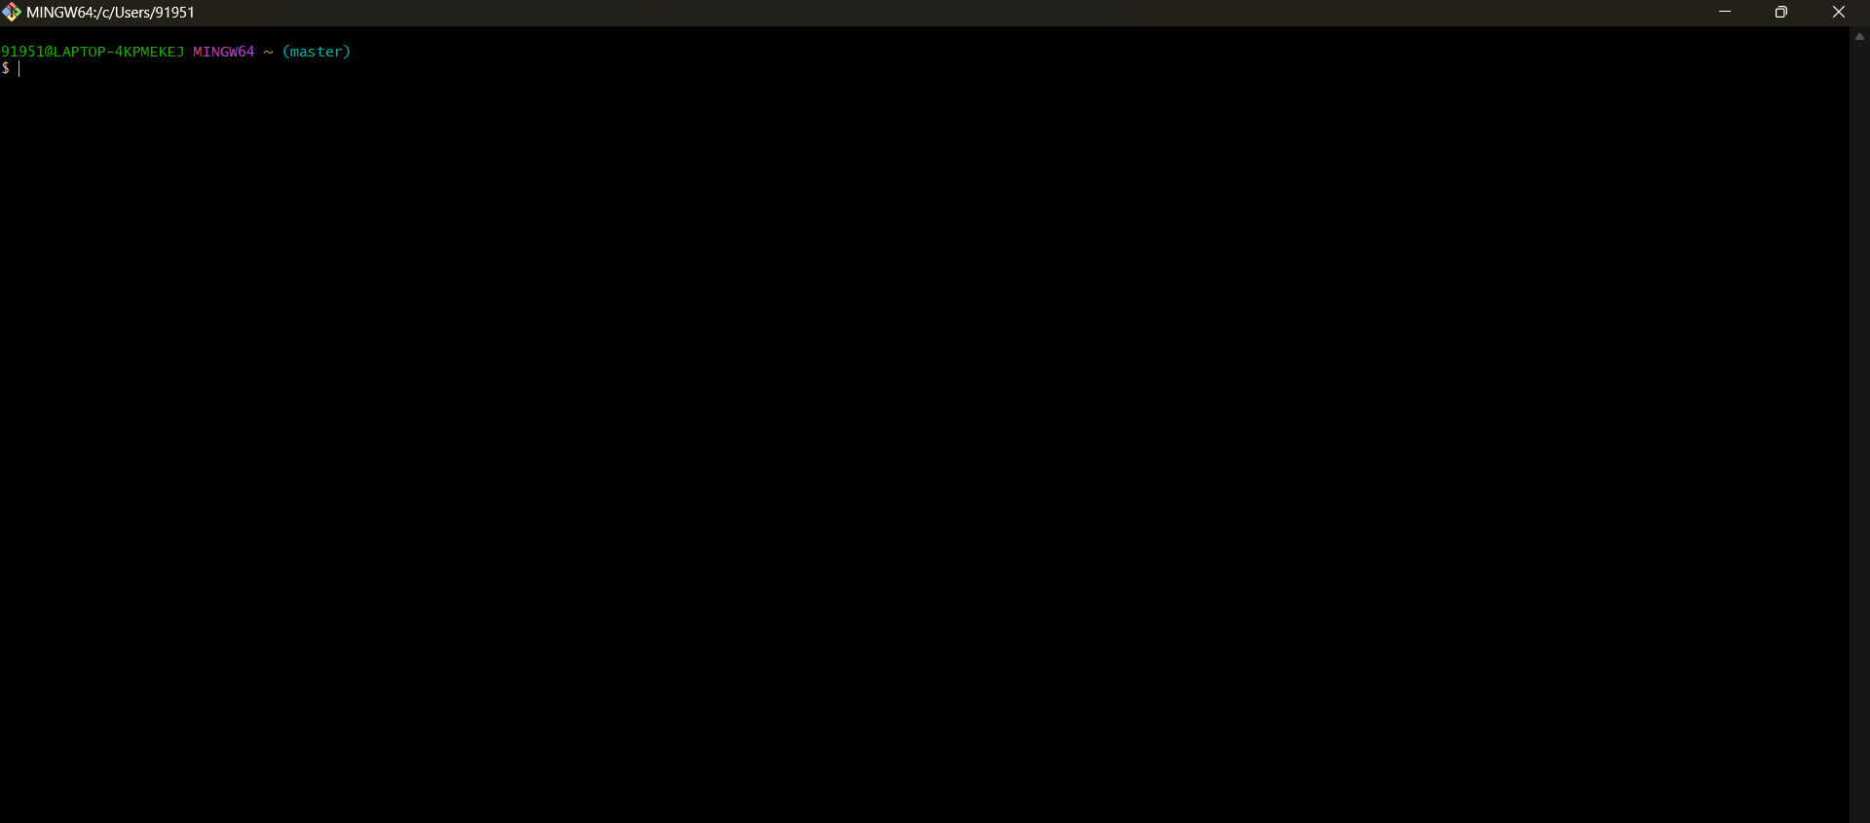

Now we need to write some commands in it.

Here are the steps which I performed:

1. Initialize Git: setting up Git in your local directory with the command `git init`. This initializes a new Git repository.

2. Clone Azure Repository: Clone the Azure repository to your local machine using the command `git clone`.

3. Navigate to Local Directory: Move to a desired location within your local directory using `cd`, such as the "Downloads" directory.

4. Create Folder and Files: Within the chosen directory, create a new folder named "akash1058" using `mkdir akash1058`. Then, navigate into this newly created folder.

5. Generate Text Files: Created Five text files within the "akash1058" folder using the `touch` command. These files will serve as placeholders for your project data.

6. Populate Files with Data: Add raw data to each text file to populate them with content. You can use the `cat` command to verify the contents of each file.

7. Prepare for Git Push:

- Stage the changes by using `git add .`, which adds all modifications to the staging area.

- Commit the staged changes with `git commit -m "Message"` to finalize the changes locally.

8. Push Changes to Azure Repository: Execute `git push origin master` to push the committed changes from your local repository to the Azure repository. This command ensures that your changes are synchronized with the central repository on Azure DevOps.

9. Verification: Confirm that the files have been successfully transferred to the Azure repository by checking the repository on the Azure DevOps platform.

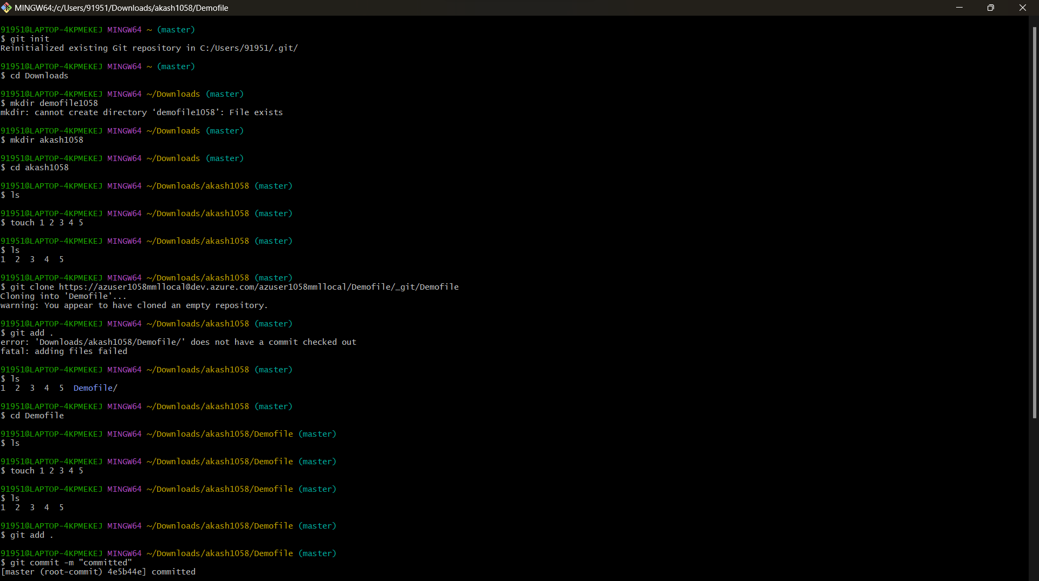

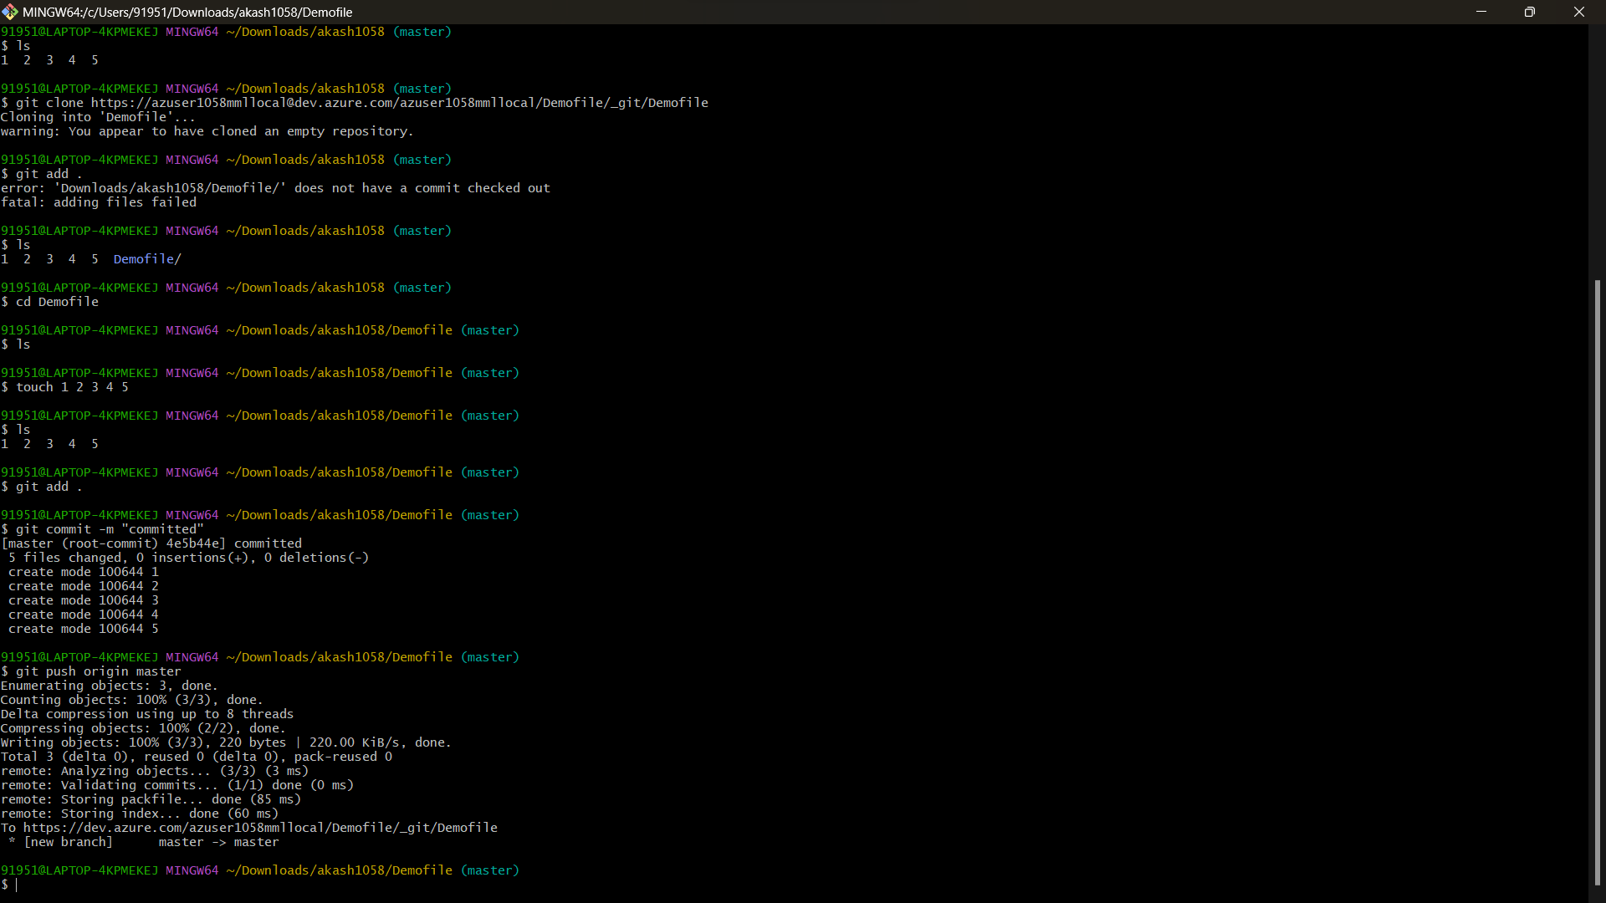

Now to validate the push is performed or not let us check in azure devops

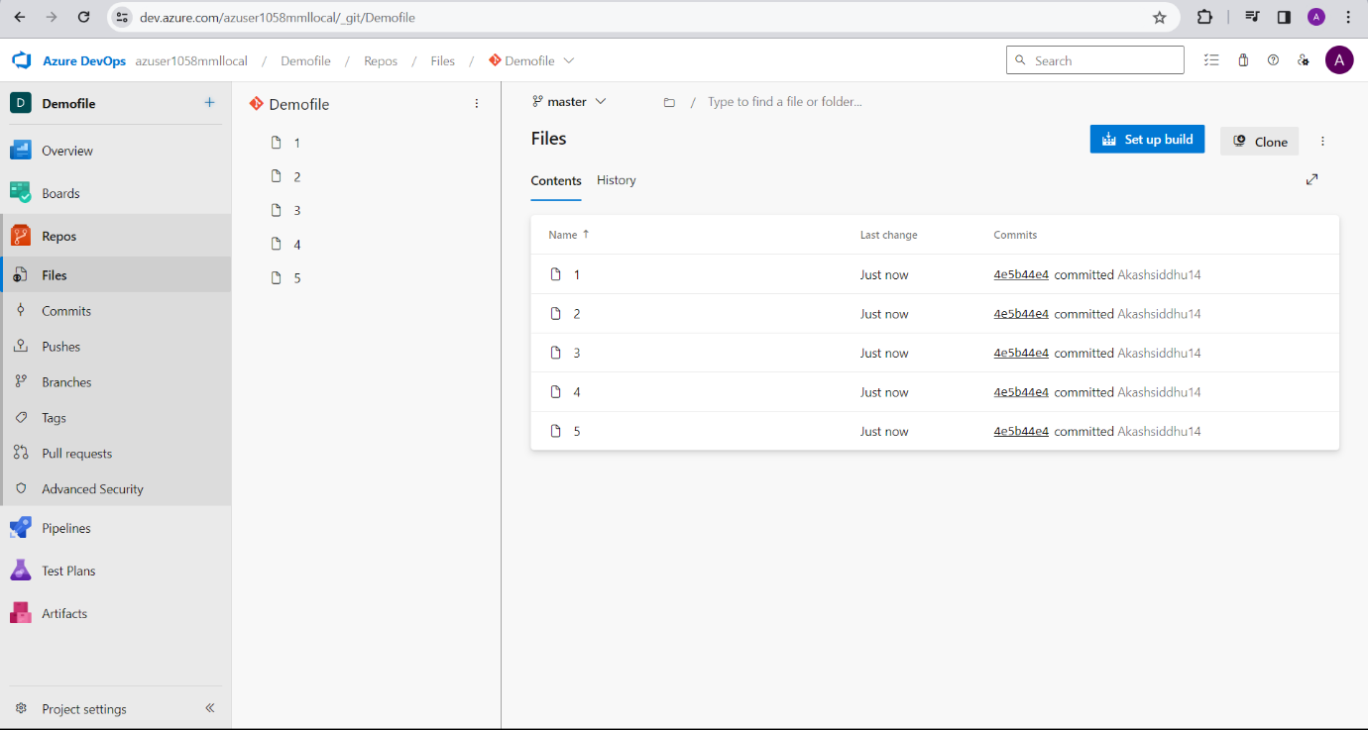

We have successfully performed the process.